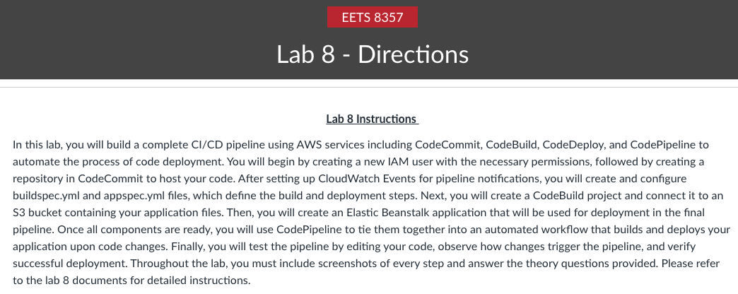

CodeCommit:
CodeCommit is a secure, highly scalable, managed source control service that hosts private Git repositories. CodeCommit eliminates the need for you to manage your source control system or worry about scaling its infrastructure. You can use CodeCommit to store anything from code to binaries. It supports the standard functionality of Git, so it works seamlessly with your existing Git-based tools.

CodeBuild:
AWS CodeBuild is a fully managed build service in the cloud. CodeBuild compiles your source code, runs unit tests, and produces artifacts that are ready to deploy. CodeBuild eliminates the need to provision, manage, and scale your build servers. It provides prepackaged build environments for popular programming languages and builds tools such as Apache Maven, Gradle, and more.

Code Deploy:
CodeDeploy is a deployment service that automates application deployments to Amazon EC2 instances, on-premises instances, serverless Lambda functions, or Amazon ECS services.

Code Pipeline:
AWS CodePipeline is a continuous delivery service you can use to model, visualize, and automate the steps required to release your software. You can quickly model and configure the different stages of a software release process. CodePipeline automates the steps required to release your software changes continuously.

Task Creating new IAM user.

- Create a new IAM user (Yourname-Pipeline) and group with policies:
“AdministratorAccess”, “AWSCodeCommitFullAccess”, & “AWSCodePipelineFullAccess”.
- Log back in as an IAM user.

PART 1: CodeCommit - Creating a repository on CodeCommit
Step 1: Create an Amazon CloudWatch Events to detect and react to pipeline execution state changes by sending an Amazon SNS notification (ADD SCREENSHOTS OF ALL STEPS)

Step 2: Create a repository named <your-name-pipeline> on CodeCommit using AWS Console and connect using HTTPS (ADD SCREENSHOTS OF ALL STEPS)

PART 2: CODEBUILD - Creating a new build in CodeBuild.
TASK 1: Create an S3 bucket named as <your-name-pipeline-lab> (ADD SCREENSHOT)

TASK 2: Create a buildspec.yml and appspec.yml file for your repository
(ADD SCREENSHOT).
Buildspec.yml:

Appspec.yml:

Theory questions:
Q) What is a buildspec file, in which stage will it be used & explain the file provided in this assignment.
Q) What is an appspec file, in which stage will it be used & explain the file provided in this assignment.
TASK 3: Create a new build in CodeBuild (ADD ALL SCREENSHOTS)
TASK 4: Start Build (ADD SCREENSHOT)

Check your build (ADD SCREENSHOT)

TASK 5: Check your artifact (ADD SCREENSHOT)
Theory question:
Q) What is an artifact? Explain it in general as well as about this lab.

PART 3: CODE DEPLOY
In this lab, we will create an Elastic Beanstalk application which will be used later in the CodeDeploy stage while adding stages in the pipeline in the next part

Creating Beanstalk App
TASK: Create an Elastic Beanstalk application with PHP as your platform (Select defaults for platform branch & version) and use the application code from s3 (ADD SCREENSHOT).

PART 4: CODE PIPELINE
Creating end to end pipeline using CodePipeline.

TASK 1: In this task, now we put together all the stages that we created in parts 1, 2, and 3. Select the appropriate and correct option for each stage to build the pipeline.
(ADD SCREENSHOTS OF EACH AND EVERY STEP)
TASK 2: Meanwhile the pipeline is getting created, you should receive notifications from CloudWatch Alarms indicating the stages being created. (ADD SCREENSHOTS)
TASK 3: Pipeline created (ADD SCREENSHOTS)

TASK 4: Now verify your deployment (ADD SCREENSHOT)

Theory question:
Q) Explain how a pipeline works in detail.

PART 5: Triggering pipeline

We will trigger our pipeline by making a small change to demonstrate how a pipeline automates the whole process.

TASK 1: Make changes to your index file (ADD SCREENSHOT)
TASK 2: As soon as your pipeline is triggered, you must have started to receive notifications from CloudWatch via SNS (ADD SCREENSHOTS)

TASK 3: Check your pipeline (ADD SCREENSHOT)

TASK 4: Check whether your pipeline is deployed successfully (ADD SCREENSHOT)

Theory question:
Q) Explain how you triggered your pipeline and how the whole process of building till deploying the pipeline was done.
TASK 5: Verify your deployment & check build history. (ADD SCREENSHOT)

CONCLUSION: We have successfully implemented an end-to-end CI/CD Pipeline using AWS CodeCommit, CodeBuild, CodeDeploy, and CodePipeline.

Terminate and delete everything in the user you have created.

End of Lab
The document is a lab guide for a course on DevOps for Network Engineers, focusing on creating and managing a CI/CD pipeline using AWS services such as CodeCommit, CodeBuild, CodeDeploy, and CodePipeline.
IAM User Creation and Permissions.

This section outlines the process of creating a new IAM user and assigning necessary permissions for DevOps tasks. ​ The user is named "Yourname-Pipeline" and is granted access to various AWS services.

Create an IAM user named "Yourname-Pipeline". ​
Assign the following policies: "AdministratorAccess", "AWSCodeCommitFullAccess", and "AWSCodePipelineFullAccess".

Log back in as the newly created IAM user. ​

CodeCommit Repository Setup.

This part describes the steps to create a repository in AWS CodeCommit for version control. ​ The repository is named after the user and is connected via HTTPS.

Create an Amazon CloudWatch Event to monitor pipeline execution state changes and send SNS notifications. ​
Set up a CodeCommit repository named "" using the AWS Console. ​

Connect to the repository using HTTPS, confirming the clone operation.

CodeBuild Configuration and Build Process

This section details the creation of a build in AWS CodeBuild, including the setup of necessary files and S3 bucket. ​

Create an S3 bucket named "" for storing build artifacts. ​
Develop buildspec.yml and appspec.yml files for the repository. ​
Create a new build in CodeBuild, specifying the service role and build specifications. ​
Start the build process and check the build status and artifacts generated.

Elastic Beanstalk Application Creation.

This part involves creating an Elastic Beanstalk application that will be used in the deployment stage of the pipeline. ​

Create an Elastic Beanstalk application using PHP as the platform. ​
Use the application code sourced from the S3 bucket.

End-to-End Pipeline Creation with CodePipeline
This section explains how to assemble all previously created components into a cohesive CI/CD pipeline.

Integrate all stages from CodeCommit, CodeBuild, and Elastic Beanstalk into a single pipeline. ​
Monitor the pipeline creation process through CloudWatch Alarms for notifications. ​
Verify the successful creation and deployment of the pipeline. ​

Triggering the Pipeline and Deployment Verification
This part describes how to trigger the pipeline by making changes to the code and verifying the deployment. ​

Make changes to the index file to trigger the pipeline.
Receive notifications from CloudWatch via SNS as the pipeline processes the changes. ​
Check the pipeline status and confirm successful deployment.

Conclusion and Cleanup

The lab concludes with a summary of the successful implementation of a CI/CD pipeline using AWS services. ​ It also includes instructions for cleaning up resources.

Successfully implemented an end-to-end CI/CD pipeline using AWS CodeCommit, CodeBuild, CodeDeploy, and CodePipeline. ​

Terminate and delete all resources associated with the created IAM user.

